Introducing Developmental Disability Through a Disability Studies Perspective
by Emily Brooks and Mariette Bates

This resource is licensed under a Creative Commons Attribution-NonCommercial-ShareAlike 4.0 International license.

Table of Contents
Introducing Developmental Disability Through a Disability Studies Perspective 1
Introduction 1
Section 1: Disability is Complicated! 1
Legal Issues, Legal Rights, and Disability 5
The Rehabilitation Act of 1973: Sections 504 and 508 (1973) 6
PL 94-142 (1975), renamed IDEA (2004), and Every Student Succeeds Act (2015) 6
The Developmental Disabilities Act (1963) 7
The Americans with Disabilities Act of 1990 7
The Olmstead v L.C. Decision of 1999 8
Section 2: Developmental Disability as a Social Construct 8
Historical Perspectives on Developmental Disability 11
IQ as Eugenics 15
Modern-Day Eugenics 15
Section 3: Self-Advocacy and Advocacy 20
The History of the Self-Advocacy Movement 20
Self-Advocacy and the Neurodiversity Movement 22
Evolving Language: Language and the Self-Advocacy Movement 23
Language and Developmental Disability 27
Putting the Social Model of Disability into Practice 28
Conclusion: Advocacy in the Future 31
References 32
Glossary 36

Introduction
Welcome! We hope our open educational resource will help you to explore and understand developmental disability from a different lens.

Section 1: Disability is Complicated!
by Mariette Bates, Ph.D.
People with disabilities are multifaceted and complex. They work, have families, drive cars, run companies and contribute to the diversity of our country and their communities. They are our neighbors, our friends, our parents and siblings. They are us! The treatment of disabled people in history, though, has been one of marginalization, stigma, and discrimination, often using the fact of disability to justify the violation of rights.
Having a diagnosis of a disability simply means that a person has a condition that might require treatment or specialized intervention – or it might not. Just because someone has a disability diagnosis doesn’t mean anything about a person’s ability, competency or character – it just means that the person identifies as having an impairment or a professional has determined that they have a particular physical or mental condition. As you’ll read below, in society we view diagnoses as being scientifically developed and reliable, but they can also be viewed as socially constructed – that is, what is seen as a problem to be fixed in one society may be viewed as quite typical in others.
In Disability Studies, we take the approach that although an individual may have an impairment, it’s the barriers they encounter in the physical environment and the lack of opportunity for employment, access to education, recreation, and housing that can ‘disable’ an individual. We see these barriers as representing the larger issue of disabling attitudes in society and pervasive disability oppression. As workers, advocates, parents or siblings, we hope that exploring disability with a critical eye can help us understand more about the interaction between disability and society, and that what we learn can make us better advocates for ourselves and others.
Although we embrace the social model of disability in disability studies – you’ll learn more about this a bit later – there are terms that society and professionals use every day to refer to disability. If you’re working in the field, it’s important to understand what the terms mean but also to be able to shift perspective and keep the social model in mind.
In our daily lives, we encounter different systems – the educational system, the medical system, or perhaps a governmental system that may be providing benefits. Each of these may have a different way of looking at disability, and different criteria for meeting that system’s definition of disability, further complicating our understanding of disability.
Remember, though, that every person is different and is an individual. Having a particular diagnosis or label only means that a person has a particular set of characteristics that seem consistent with a particular condition. But even people with the same diagnosis may experience the condition in different ways, with different types of support needs. So, for example, someone with the diagnosis of Down syndrome may need support in many activities of daily living like dressing or eating, and may need a great deal of support in school. Another individual with the same diagnosis of Down syndrome may graduate from high school with the same diploma as non-disabled classmates and not need support at home at all.
Physical impairments are conditions that largely affect our senses and mobility – our ability to move through the environment easily. People with physical disabilities may use assistive devices to help them navigate living – wheelchairs, or walkers, prosthetics, hearing aids, glasses, large print materials, or technology to help them communicate with others.
Sensory impairments affect our ability to see or hear, or to experience the environment the same way people without these conditions do. Hearing impairments and vision issues like low vision or blindness are included here. If the sensory issue occurs before age 21, the child may be considered to have a developmental disability. Some people have chemical sensitivity, so they have different reactions to odors from the kinds of cleaning materials or perfumes in grooming products than others do, and can have very severe reactions. And some people have a sensitivity to particular kinds of light as well.
Spinal cord injuries are caused by accidents, such as automobile crashes, falls, domestic or other violence, or other trauma to the spine. These can occur at any age. Depending on where the injury occurs, different parts of the body might be affected and the injured person may use a wheelchair for mobility, or may not have use of their arms. People with injuries higher up on the spinal cord may use a respirator to help them breathe.
Traumatic Brain Injuries (TBI) are also caused by accidents – falls where a child or adult hits their head, or a soldier experiences shock to the brain caused by a bomb or gunshot wound. These can also be caused by domestic violence or other violence that affects how the brain functions.
Limb impairments can be caused by inherited genetic issues, by injuries caused to a developing fetus (like the umbilical cord wrapping around fingers that inhibits their growth) or by amputations because of accidents, trauma, or chronic illness like diabetes.
Club feet and cleft palates are very common birth defects, and in most cases the cause isn’t known, but is due to a combination of genetic and environmental factors. In developed countries, these conditions are typically corrected in childhood with surgery, but in much of the world people with club feet and people with cleft palates face social barriers to work and relationships.
Genetic disorders can cause many different disabilities. DNA – deoxyribonucleic acid -carries the code for all of our genes (a gene is just a sequence of DNA). When humans reproduce, the DNA from their parents is copied and recombined. Because humans are so complex, it’s not unusual for parts of DNA to not copy correctly – either some DNA is left out or some DNA is copied too many times. When a sequence of DNA is left out, it’s called a ‘deletion.’ When DNA is copied to many times, it’s referred as a ‘DNA repeat.’ How these deletions or repeats are expressed in a person depends on which of our 23 pairs of chromosomes has deletions or repeats and how that particular sequence of DNA molecules is expressed in a human being. ALL of us have both deletions and repeats of DNA in some of our chromosomes and genes, but not all of us have genetic disorders that are expressed in ways that might cause us to be thought of as different from ‘typical’ people.
Image by Gerd Altmann from Pixabay.
Developmental Disabilities are a group of disabilities, including ADHD, Autism Spectrum Disorder, Cerebral Palsy, Intellectual Disabilities, Hearing Loss, Learning Disability, Vision Impairments, and delays. These occur before age 21 and are expected to last throughout the lifetime.
Intellectual disabilities are disabilities that occur before age 21 – during a person’s developmental stage of life – and are likely to be lifelong. A person with a developmental disability may require support in learning (both academic and experiential learning), judgment and reasoning. Some people with intellectual disabilities can live independently, work, and have families, while some need maximum support in all aspects of daily living.
Common developmental disabilities include Attention Deficit/Hyperactivity Disorder (ADHD), autism spectrum disorder, cerebral palsy, hearing loss, intellectual or cognitive disability, learning disability, vision impairment, or neurological impairments.
Intellectual or cognitive disabilities require some specialized assistance in learning. There is a wide range of people who have this diagnosis, so we can’t assume anything just because a person has a label of intellectual disability. Most people with intellectual disabilities are able to acquire information and skills in order to live independently and work as adults. A small percentage, however, need lifelong maximum support in activities of daily living like eating, showering, and dressing.
There are many causes of intellectual disability, including genetic disorders, falls, malnutrition, environmental pollution, birth trauma, infections, child abuse and accidents.
Autism Spectrum Disorders are very common – according to the Centers for Disease Control from 2017, 1 in 59 children has been diagnosed with ASD. The criteria for a diagnosis of ASD are complicated. You can read the Centers for Disease Control criteria for a diagnosis of autism spectrum disorder here.
While ASD is sometimes characterized as a communication disorder, increasingly, some people believe autism is simply a different way of seeing the world, and the behaviors that accompany autism should be viewed as a form of diversity rather than something that needs professional intervention. It’s important to remember that everyone with the diagnosis of ASD is an individual and nothing can be assumed about her or his abilities or need for support simply because of the diagnosis. Not every autistic person has every trait named in the diagnostic criteria, or experiences the same characteristic in the same way. While there is a growing movement of autistic pride, each autistic person experiences autism in their own way, and each may require different types of support for housing, education, employment, relationships, communication, healthcare, and activities of daily living.
Learning Disabilities are very common and can be thought of as a processing disorder, where information is process a bit differently than with people who don’t have this disability. One way to accommodate children and adults with learning disabilities is to provide extra time to process information or to express ideas. Dyslexia (difficulty in reading), dysgraphia (difficulty in writing), and dyscalculia (difficulty with arithmetic), are common learning disabilities. Another common learning disability is attention deficit/hyperactivity disorder (ADHD) which results in difficulty in sustaining focus.
Cerebral Palsy is a very common developmental disability that causes people to experience stiff muscles or difficulties with coordination that causes a jerky motion. In some people it causes a continuous writhing motion. Some people with cerebral palsy can walk, while others need to use a wheelchair for mobility. A small percentage of cerebral palsy is inherited, but most cerebral palsy is caused by birth trauma or another kind of trauma, such as an accident.
Some people with cerebral palsy have cognitive or learning disabilities, while many do not. So like having a diagnosis of any other disability, having a diagnosis of cerebral palsy doesn’t imply anything about intelligence, judgment or ability to work.
Epilepsy is a seizure disorder, where neurons in the brain can cause several different types of seizures. Some seizures are minor and the individual experiencing them loses contact with the environment for a brief period of time. Some seizures might cause a person to have repetitive motions for a minute or more. And some seizures are more involved and cause the person experiencing them to lose control of muscles for a period of time.
Neurological impairments are a collection of conditions resulting from issues with the nervous system that may cause a range of symptoms. Some neurologic impairments are hidden disabilities that result in the need for some specialized assistance. Some neurological impairments have a genetic component, while others do not. Neurological impairments include narcolepsy, neurofibromatosis, tuberous sclerosis, spina bifida, Prader-Willi syndrome, and Tourette Syndrome.

Legal Issues, Legal Rights, and Disability
Citizens of the United States obtain rights in three different ways: they are enumerated in our Constitution and Bill of Rights; they are enacted through legislation (local, state or federal) and codified in regulations that further explain or interpret the legislation; or they are the result of court decisions that further define our rights, how they should be interpreted and commonly understood.
Citizens with disabilities have the same rights as citizens who do not have disabilities, among them the right to vote, to own property and dispose of it as they wish, the right to marry, the right to privacy, the right to worship, and freedom of speech, and the right to due process.
After World War II and the Nuremberg Trials, an important concept of informed consent became the standard when medical or other interventions are recommended. This means that a person needs to consent to treatment and needs to understand both the benefits of the treatment and any risks that might derive from the treatment. If we go in for surgery, we are asked to sign a consent form that details what could happen to us as a result of the surgery or of medications that are prescribed. Informed consent also applies to issues like behavior management interventions.
One issue that has involved informed consent and is the source of some tension at the moment is the issue of guardianship. In New York State, the law presumes that anyone who is over 18 can make his or her own decisions. Some individuals with intellectual disabilities may need support in order to make decisions about health care, whether or not to have children, or other life choices. Parents can retain the power to make these decisions for their adult children with intellectual or developmental disabilities if they go to court and petition to remain their adult child’s guardian. Sometimes parents are awarded limited guardianship – they can make some decisions for their adult child with a disability, but not all decisions. Recently a new idea – supported decision-making – is gaining ground. The idea is that the person appoints someone he or she trusts to assist in making important decisions without giving up her or his rights.
When a person with a disability enters public care (or private care) they often give up some rights or parts of rights in order to be eligible for the care they receive. For example, if a person is moving into a group home or apartment program that is run by a service agency, s/he might be giving up some rights to privacy or self-determination in order for the service agency to provide what’s needed. For example, if the person is living with six people and there are two staff members, and five of the residents want to go swimming on Tuesdays, the person who would prefer to stay home may end up going swimming because there is no one to stay home with him or her. Or if the person is used to having a private room s/he may be living with a roommate, at least for a period of time. These issues are typically spelled out so that they are clear before the person moves from one setting to another. While the goal of these organizations should be to provide as much choice as possible – to provide services in the ‘least restrictive environment’ possible, practical issues sometimes mean choices may be limited.
There are five basic laws and regulations that affect disabled children and adults. These are explained below:

The Rehabilitation Act of 1973: Sections 504 and 508 (1973)
The Rehabilitation Act of 1973 is very important because its Section 504 mandated that any public entity receiving federal funds needed to be accessible to individuals with disabilities. Since hospitals, federal courts, transportation systems and educational institutions received federal funds, what this meant was that for the first time people who had mobility or sensory issues could take advantage of higher education or the court system, or have access to public transportation. Section 508 mandated that internal federal systems – for example, the telecommunications systems- had to be accessible. This opened the door for people with disabilities to be employed by the federal government. One of the important principles included in the Rehab Act of 1973 was the idea of ‘least restrictive alternative’ or ‘least restrictive environment.’ What this means is that when services are needed – whether they are rehabilitative or educational – they should be provided in the least possible segregated setting, and that people with disabilities should only receive segregated services when absolutely necessary. So, rehabilitation services should be provide in the community, not in segregated settings like hospitals or institutions.

PL 94-142 (1975), renamed IDEA (2004), and Every Student Succeeds Act (2015)
Public Law 94-142, the Education of All Handicapped Children Act – further modified in and renamed Individuals with Disabilities Education Act (IDEA) mandated a free and appropriate education to all children, whether or not they had a disability. IDEA expanded on this idea, and recent reauthorizations have made some improvements. Important to the original and subsequent modifications is the idea which was embedded in the Rehab Act of 1973 – the idea of ‘least restrictive setting.’ Extending this idea is the concept that the default educational setting should be one where the child with a disability is included or integrated, and only removed from an inclusive classroom for a specific, documented reason (therapy or another documented reason). Also included is the mandate for a written individualized education plan (IEP) that describes the student’s needs and the services to be provided to assist in that child’s education, due process and appeals, formalized input from parents and the student, and periodic review. Additional supports needed by the student are detailed in each student’s IEP.

The Developmental Disabilities Act (1963)
The Developmental Disabilities Act was initially authorized in 1963 by President Kennedy. It is administered under the federal Administration for Community Living (ACL). It is reauthorized periodically and changes are made depending on current needs. For example, in 1975, the State Protection and Advocacy systems were created to address civil rights violations. The Act of 1978 provided for the creation of Developmental Disabilities Planning Councils in each state. These Councils are awarded federal funds and are charged with funding pilot projects that can be widely adopted if they prove to be viable and useful. The DD Act also provided for the creation of University Centers of Excellence in Developmental Disabilities (UCEDs) which are charged with training clinicians and other staff to work in the community with individuals with developmental disabilities. Protection and Advocacy programs in each state can help with bringing legal actions in cases of violations of individual rights, but they frequently bring actions against more systemic violations of rights. Protection and Advocacy Programs address legal rights of individuals with developmental disabilities, assistive technology, voting accessibility and traumatic brain injury. You can read more about the Developmental Disabilities Act here: https://acl.gov/about-acl/history-dd-act

The Americans with Disabilities Act of 1990
The Americans with Disabilities Act of 1990 is the most sweeping legislation for persons with disabilities in the United States. The ADA was signed by President George H. W. Bush in July of 1990, and took effect two years later. The ADA and its amendments of 2008 provide for reasonable accommodation in employment, communication, transportation, and in the use of community resources, like local businesses. While the ADA lays the groundwork for forcing accessibility, it also puts the burden of complaint upon disabled citizens. While the Office of Civil Rights will investigate and prosecute violations of the ADA, reliance for identifying instances of violation rests with individuals with disabilities.
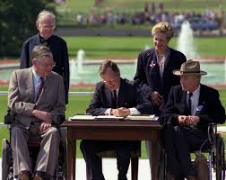
Obama archives. President Bush signing the ADA. Far right (in hat) is Justin Dart.

The Olmstead v L.C. Decision of 1999
The Olmstead v L.C. Decision of 1999 was a lawsuit filed by two women living in the Georgia Regional Hospital. Each of the women wanted to live in the community and in each case the professionals treating the women agreed that they would be able to do that. The State of Georgia had not placed the women arguing that their budget was inadequate to support them in the community. The case went all the way to the Supreme Court, which found that “under Title II of the ADA states are required to place persons with mental disabilities in community settings rather than in institutions when the State’s treatment professionals have determined that community placement is appropriate” and when other conditions have been met. The decision also reaffirmed that individuals with disabilities should not be excluded from life in the community but instead should be included in society. You can read the Supreme Court decision here: https://www.law.cornell.edu/supct/html/98-536.ZS.html.

Section 2: Developmental Disability as a Social Construct
Disability studies views disability in general as a social construct. Rather than one universal experience of disability, this view acknowledges that disabled people have different experiences across time and cultures, and ideas about what disability means and who is disabled are defined by humans. Disability studies also recognizes a difference between impairment, or body-mind difference, and disability.
The same concepts apply when we talk about developmental disability. People can have impairments in their bodies and brains. For instance, a person may communicate nonverbally. A person may have seizures. A person may process the world in a way that makes reading harder. Calling developmental disability “social constructed” does not mean that all of our bodies are the same. It is does not mean that all of our minds are the same. We should not ignore differences. We can still talk about how impairments can be difficult for people to experience. However, it is our society that makes meaning from difference. Our society values or devalues differences. Our society creates diagnoses like autism, epilepsy, and dyslexia. By requiring reading, prioritizing talking over other communication, or allowing strobe lights and other seizure triggers, society disables people with specific impairments.
Who is viewed as having a disability, and how does this shift throughout time? Thomas Armstrong argues that developmental disabilities, learning disabilities, and mental health disabilities are defined by the societies and eras in which we live. He writes, “No brain exists in a social vacuum. Each brain functions in a specific cultural setting and at a particular historical period that defines its level of competence” (2010, p. 15). People with the same brain differences are regarded completely differently dependent on the social context. The places and times we live in make things easier or harder for people with developmental disabilities. Armstrong posits that “being at the right place at the right time seems to be critical in terms of defining whether you’ll be regarded as gifted or disabled” (p. 15).
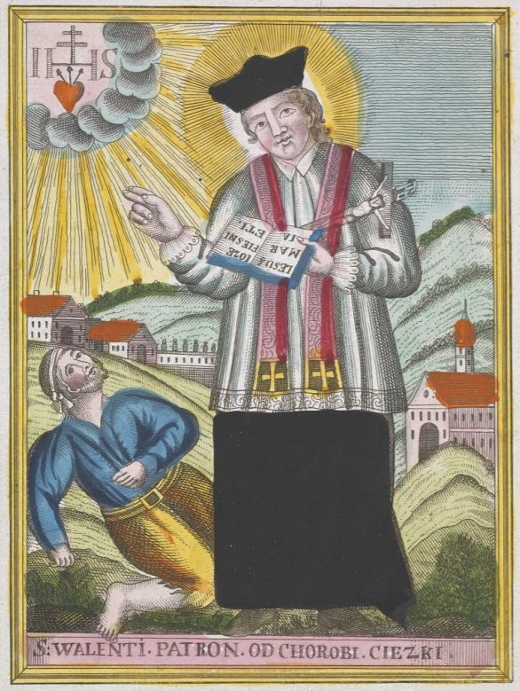
People with developmental disability were treated differently according to time, culture, and understanding of disability. Here, a man with epilepsy is blessed by Saint Valentine.
Saint Valentine blessing an epileptic. Colored etching. Wellcome Collection. CC BY

Disability historian Kim Nielsen (2012) notes that the concept of disability changed throughout American history. The idea of what “disability” meant was not the same. Before Europeans colonized North America, some indigenous people viewed individuals with disabilities differently than we do today: “A young man with a cognitive impairment might be an excellent water carrier. That was his gift. If the community required water, and if he provided it well, he lived as a valued community member with no stigma” (2012, p. 3). People with what we now call “developmental disabilities” were included in the community. Often, they were not viewed negatively. Nielsen explains, “Most indigenous communities did not link deafness, or what we now consider cognitive disabilities, or the shaking bodies of cerebral palsy, with stigma or incompetency” (2012, p. 4). Once European settlers began colonizing North America, they brought disease and violence. War and illness shifted resources among groups and changed group values. These changes impacted disabled people. The same people who were included in their communities might not have a place anymore. Nielsen explains that suddenly, for people with impairments including what we now call developmental disability, “Though they may have possessed excellent storytelling or basket-making skills, wisdom, the ability to nurture children, these things meant little in the face of overwhelming communal stress” (2012, p. 18). In other words, colonialism brought disease and war. New and dangerous conditions made disabled people less valuable to the group, less likely to be a part of the group, and more likely to die.
European colonists brought different views of people with developmental disability. Kim Nielson explains that in the 1600s, people with some physical impairments could be accepted because they participated in work. At the same time, “those that today we would categorize as having psychological and cognitive disabilities attracted substantial policy and legislative attention by Europeans attempting to establish social order, capitalist trade networks, and government in sixteenth- and seventeenth-century North America” (Nielson, 2012, p. 20). Europeans made laws and policies that impacted disabled people’s lives. In Colonial America, some people with developmental disability and psychiatric disability were sent to institutions like almshouses and asylums, while others lived in the community or were locked away at home. Nielson explains, “The decades surrounding the American Revolution were a period of transition for those with mental and cognitive disabilities, in which some were referred to experts outside the family and some were not” (p.38). Nielson sees this as a shift toward the medical model of disability, in which disability is seen as an individual problem that requires medical intervention. People started turning to doctors to help them understand their family members’ disabilities.
Disabled people were not the only ones impacted by negative ideas about disability. People of color, women, immigrants, and people now considered LGBTQIA (lesbian, gay, bisexual, transgender, intersex, and asexual) were impacted by ableism and the medical model of disability. The concept of feeble-mindedness was misused to control and oppress marginalized people like woman and people of color. Ableism is structural discrimination against disabled people. Ableism shares roots with other oppressions, like racism, sexism, homophobia, transphobia, and xenophobia. Nielson notes, “The racist ideology of slavery held that Africans brought to North America were by definition disabled. Slaveholders and apologists for slavery used Africans’ supposed inherent mental and physical inferiority, their supposed abnormal and abhorrent bodies, to legitimize slavery” (p. 42). Slavery was inhumane and operated through racism. Slavery also relied on negative ideas about disability. As medicine took hold in the 1800s, “medical expertise regarding women’s biological deficiencies buttressed the exclusion of white women from higher education, voting, and property ownership” (Nielson, 2012, p. 66). So medical model disability language was used to deny women’s rights. People today considered LGBTQIA were “diagnosed as sexual perverts” and were deported, sterilized, and institutionalized (Nielson, 2012, p. 115). Indigenous people were mistreated, killed, and barred from citizenship, while potential immigrants were scrutinized for signs of disability. During the time between the American Revolution and the Civil War, “Disability, as a concept, was used to justify legally established inequalities” (Nielson, 2012, p. 50).
Samuel Gridley Howe believed people with developmental disability could learn and work, and helped establish schools, including those that served students with developmental disability (Nielson, 2012, pp. 67-68). Asylums were segregated racially. Institutionalized people of color and indigenous people received worse treatment (Nielson, 2012, p. 92). Institutions exposed disabled people to extreme abuse and neglect. People with developmental disability were among the most targeted for institutionalization.
The late 1800s to the early 1900s was when institutions really became central to the plight of people with developmental disability. Starting in the mid-1800s, children and adults with developmental disability were sent to “training schools,” “colonies,” and “institutions for the feeble-minded” (Jirik, 2014). There were smaller private institutions, as well as an influx of large public institutions. Katrina Jirik (2014) explains that “As the laws changed, allowing lifetime commitment to the institutions,” they went from educating people who weren’t allowed in public schools due to disability to calling it “vocational training” to use inmates for “the labor needed to run the institution” (2014). Institutions became places where people were warehoused for their whole lives. People with developmental disability faced neglect, abuse, medical experimentation, and death in institutions across America.

Historical Perspectives on Developmental Disability
As eugenics became popular, institutions became places to separate and sterilize Americans with developmental disability and other disabilities (Jirik, 2014). Eugenics is the idea that some people are smarter, healthier, and better because of their genes. In 1883, Sir Francis Galton came up with the term “eugenics,” meaning “well-born” (Kurbegovic & Dyrbye, n.d.). He believed that by encouraging certain people to marry and have children while discouraging or stopping other people from doing so, humans would improve and get rid of problems. Galton, who was cousins with Charles Darwin, is known as the father of eugenics. As Lennard Davis (2013) writes:
On the one hand Sir Francis Galton was cousin to Charles Darwin, whose notion of the evolutionary advantage of the fittest lays the foundation for eugenics and also for the idea of a perfectible body undergoing progressive improvement. As one scholar has put it, “Eugenics was in reality applied biology based on the central biological theory of the day, namely the Darwinian theory of evolution” (Farrell 1985, 55). Darwin’s ideas service to place disabled people along the wayside as evolutionary defectives to be surpassed by natural selection. So eugenics became obsessed with the elimination of “defectives,” a category which included the “feebleminded,” the deaf, the blind, the physically defective, and so on. (Davis, 2013, p. 3).
Charles Darwin was a scientist and explorer. In 1859, his theory of evolution, based on his observation of animals, was published. The title of his book was On the Origin of Species. One part of Charles Darwin’s theory was natural selection. In 1859, Darwin wrote, “It may be said that natural selection is daily and hourly scrutinising, throughout the world, every variation, even the slightest; rejecting that which is bad, preserving and adding up all that is good” (1859/2009, p. 83). Natural selection meant that the animals (including ancestors of humans) who adapted best to their environment and had the best qualities would be most likely to survive, mate, and have offspring. The genes of the “fit” animals would also live on in the successful animals’ descendants. On the other hand, natural selection also meant that the least fit animals, who did not adapt “well,” would be unlikely to be chosen as a partner, and therefore pass their genes down to future generations. One biologist, Herbert Spencer, framed natural selection as the idea of “survival of the fittest” (Kurbegovic, 2014).
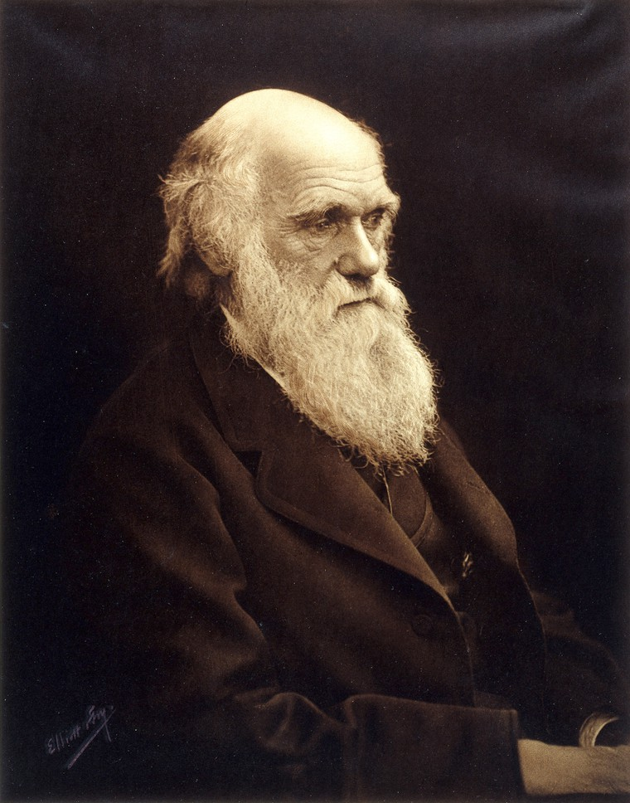
Charles Darwin.
Portrait photograph of Charles Darwin. Credit: Wellcome Collection. Public Domain
People got excited by Charles Darwin’s theories. Some people began to think that natural selection should apply to human beings in society. Erna Kurbegovic (2014) says,
Social Darwinists tried to explain inequality between individuals and groups by misapplying Darwinian principles. Thus, those who were successful were seen as superior to those who were not. This type of thinking helped set the stage for the eugenics movement to emerge. (Kurbegovic, 2014).
Social Darwinists used Darwin’s theories to try to understand society and thought that groups of people who were struggling were biologically worse.
Natalie Ball (2013) describes how Charles Darwin contributed to eugenics. Ball explains that Darwin’s theories advanced biology and genetics research, so people used his theories to justify eugenics. She writes,
The segregation, sterilization, and murder of various groups was justified by some as being done for the greater good of evolution – those groups were considered to be ‘less fit’, and by preventing their reproduction, advocates argued that the human race would improve and evolve into a better species. (Ball, 2013).
Darwin’s part in the eugenics movement is shown by his family members, including his cousin Sir Francis Galton, the father of eugenics, and two of his sons, who were involved in eugenics leadership and promotion (Ball, 2013).
Was Charles Darwin himself a eugenicist? Eugenicists are people who studied, practiced, and believed in eugenics. In his book The Descent of Man, he included racist arguments that fit into eugenicist thought, while arguing against laws controlling who had babies (Ball, 2013). But as Natalie Ball (2013) writes, “Whether or not he would have agreed with it, the theory of evolution and natural selection provided a scientific and theoretical basis for eugenic ideas and actions” (Ball, 2013). Arguing about whether Charles Darwin was or was not a eugenicist is not important. What’s important is how his ideas supported eugenics as a legitimate science.
Eugenics is part of the history of people with developmental disability. Eugenicists wanted “better” people to have children and live freely. Eugenicists thought some people weren’t worthy of having children, living in the community, or even being alive. In America, people thought of eugenics as a “science.” Many Americans supported public policies based on eugenics. At Ellis Island, disabled immigrants, including immigrants with developmental disability, were judged and deported (Nielson, 2012, p. 103). States passed laws to sterilize disabled people. American eugenicist Harry Laughlin’s “model sterilization law became internationally renowned, eventually taken up by Adolf Hitler in his own bid for a national racial purity” (Nielson, 2012, p. 102). In 1927, the United States Supreme Court said it was acceptable to sterilize people with developmental disability. It didn’t matter if people wanted to have children. The Buck v. Bell case said doctors could sterilize disabled people without their permission. The Supreme Court said it was best for public health to stop people with developmental disability from having children. They believed that parents passed developmental disability to their children (Buck v. Bell, 1927).
American eugenics made a worldwide impact. As Nancy E. Hansen, Heidi L. Janz, and Dick J. Sobsey write (2008), Nazis put laws in place with “similar, if more radical, eugenic understandings [which] resulted in the systematic murder of almost 250,000 disabled people during the period of National Socialism in Germany” (pp. S104-S105). Some Nazi policies were based on American and European laws. Other Nazi laws went further by killing people they saw as unworthy. One group Nazis targeted were people with disabilities.
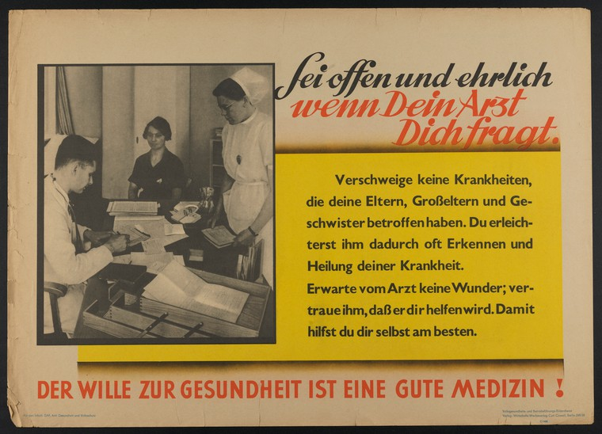A 1933 Nazi propaganda poster tells Germans to talk to their doctors about genetic disabilities.
People should be open and candid with their doctors about hereditary illnesses, so that the German state can act to eliminate them. Color lithograph, 1933/1945. Credit: Wellcome Collection. CC BY
Eugenics and Nazism play a role in autism history. Historians credit both Dr. Hans Asperger and Dr. Leo Kanner with creating the autism diagnosis (Czech, 2018, p. 4). The two doctors each had “types” of autism named after them—Kanner’s autism and Asperger syndrome (Silberman, 2015). Today, different autistic people with different support needs share the same disability name. During the Nazi regime, Asperger was a doctor in Austria. Some of Asperger’s ideas about autism changed our understanding of developmental disability. People in English-speaking Western countries often thought Asperger resisted the Nazis and protected disabled people (Czech, 2018, p. 3). Newly-available documents from Nazi times show that the real story is more complicated. According to Herwig Czech (2018), Asperger referred at least two children with developmental disability to Am Spiegelgrund. Am Spiegelgrund was an institution that Nazis used to murder disabled people (p. 20). When Nazis sterilized disabled people, Asperger seemed ambivalent. New facts make older stories about Asperger harder to believe. Czech suggests to think about Asperger’s discoveries about autism in context (p. 32). In other words, remember that Asperger contributed to present thinking about developmental disability, but don’t forget his actions in Nazi-occupied Austria. As Czech points out, the roots of the autism diagnosis comes from a time of eugenics.

IQ as Eugenics
Eugenicists considered people with developmental disability genetically inferior. People with intellectual disability were seen as a threat. The invention of intelligence quotient (IQ) testing helped eugenicists to segregate people with intellectual disability. Thomas Armstrong (2010) explains how IQ testing came about:
In 1905 psychologist Alfred Binet was asked by the Paris public school system to devise a test that would help predict which students would be in need of special education services. He developed the original test, upon which IQ scores would be based, but his belief was that students could improve their performance on the test through further development and learning. It was a German psychologist, William Stern, who actually gave the test a ‘score’ that became the intelligence quotient of an individual. The most significant changes in IQ testing, however, took place when American psychologist Henry Goddard brought Binet’s test and Stern’s score to the United States. In contrast to Alfred Binet, Goddard believed that the IQ test represented a single innate entity that could not be changed through training. (pp. 141-142)
Eugenicists thought that intelligence was genetic, unchangeable, related to social and financial success, and necessary for moral citizenship (Roige, 2014). IQ tests were used to label people as “feeble-minded,” which put them at risk of being institutionalized and sterilized (Roige, 2014). According to Kim Nielson (2012), “Many in power… used Gregor Mendel’s scientific work on plant genetics and the newly developed Binet-Simon intelligence test to argue that criminality, feeble-mindedness, sexual perversions, and immorality, as well as leadership, responsibility, and proper expressions of gender, were hereditary traits” (Nielson, 2012, p. 101). By saying that morality and intelligence were passed down through families, scientists argued for laws that restricted people who fell outside of the norm. IQ scores were treated as evidence for the kind of lives people were allowed to lead.

Modern-Day Eugenics
Eugenics might seem like it should be a concept from the past, but unfortunately, it continues in present-day disability policy. Despite their eugenicist history, IQ tests still are used to decide disability diagnosis, schooling, and employment, as well as “ in courts…if the person is capable of informed consent or of parenting” (Roige, 2014). In other words, IQ scores or a diagnosis of intellectual disability can be used to restrict rights. Nancy E. Hansen, Heidi L. Janz, and Dick J. Sobsey (2008) state, “There are disturbing similarities between Nazi arguments concerning ‘quality of life’, ‘useless eaters’, or ‘lives less worthy’ and discussions of disability currently taking place among ‘mainstream’ geneticists and bioethicists advocating a value scale of humanness” (p. S105). Bioethics relates to the study moral questions about life and living beings. One famous philosopher, Peter Singer, has debated whether a baby with a disability who needs expensive healthcare has a right to life. Hentoff (1999) quotes Singer as writing that “It does not seem wise to add to the burden on limited resources by increasing the number of severely disabled children” in Should the Baby Live? and in Practical Ethics, “that the parents, together with their physicians, have the right to decide whether ‘the infant’s life will be so miserable or so devoid of minimal satisfaction that it would be inhumane or futile to prolong life’” (Hentoff, 1999). Reading Singer’s work can be jarring and upsetting from a disability studies lens. Singer’s arguments show that eugenics is still discussed and debated. This is part of what Hansen, Janz, and Sobsey are talking about when they write that there are “disturbing similarities” between eugenic arguments of Nazis and modern bioethicists (2008, p. S105). The authors also mean that some people who study and give medical advice about genes use language of eugenics when referring to people with genetically-linked disabilities. There have been many advances in genetics in the twenty-first century, from the Human Genome Project sequencing DNA in 2003 to present-day commercially-available genetic testing kits (Roberts & Middleton, 2017). When parents-to-be go to the doctor, they can find out whether their future children are likely to have an impairment linked to their genes. For instance, a doctor can tell somebody whether their child is likely to have developmental disability like Fragile X syndrome or chronic illnesses like cystic fibrosis. A genetic counselor is a professional who understands genetic conditions, discusses test results, and advises patients of options for treatment and reproduction. A genetic counselor might give advice to somebody who finds out through screening during pregnancy that the embryo has an impairment such as Down syndrome, spina bifida, hydrocephalus, or a heart condition. In this scenario, the genetic counselor would advise their patient about options to continue with or terminate the pregnancy.
One area of ethical concern is prenatal screening. During pregnancy, future parents can find out whether their child will have certain impairments. Doctors can diagnose some impairments that are linked to genetic or physical differences in fetuses. Down syndrome is one example of a developmental disability that can be diagnosed prenatally. A consequence of prenatal diagnosis in an ableist world is reducing the populations of people with certain impairments. A person can end a pregnancy if they find out the embryo has an impairment. For instance, “Since prenatal screening tests were introduced in Iceland in the early 2000s, the vast majority of women—close to 100 percent—who received a positive test for Down syndrome terminated their pregnancy” (Quinones, 2017). Julian Quinones explained that about eighty percent of expecting parents got the screening test, which involves “an ultrasound, blood test and the mother’s age” to estimate risk factors of genetic disabilities (Quinones, 2017). Compared to other countries, very few people with Down syndrome are born in Iceland each year.
Scientists are working hard to research genes and physical signs of more impairments. One developmental disability that scientists want to understand better is autism. There are large-scale research studies about autism and genetics. One giant research study is SPARK for Autism, which is aiming for thousands of genetic samples from autistic people and their families around the United States. SPARK says its purpose is “to help scientists find and better understand the potential causes of autism. … What we collect and learn will be shared with many autism researchers to help speed up the progress of autism research” (Simons Powering Autism Research, 2019a, para. 1). But when it comes to genetics and disability, disability rights groups question what will be done with the new information scientists find.
Currently medical professionals diagnose autism based on people’s behavior and developmental history. But what would it mean if autism could be tested for genetically, like with Down syndrome, Fragile X syndrome, and other impairments? Pat Walsh, Mayada Elsabbagh, Patrick Bolton and Ilina Singh (2011) write about how researchers are looking for a biomarker for autism—a measurable, predictable biological indicator of a specific condition that can identify “at risk” people, diagnose a condition, and/or provide “personalized treatments” (p. 605). Despite their scientific interest, Walsh et al. know that there could be ethical problems with finding a biomarker for autism. Autism is different for everyone, and people’s experiences with being autistic change over time. Walsh et al. (2011) said that “it is important that biomarker discovery in autism does not result in children being given a biological label that fixes and defines their potential and treatments” (p. 606). They are saying that it would not be ethical to use genetic testing to label a child with a type of autism. Then the child could become limited by what the test said. Another ethical issue is whether to view autism as a difference or a disability. Walsh et al. discussed how some disability rights and neurodiversity advocates have argued for viewing autism as a difference, not a disability. If finding a biomarker could lead to “prevention” of autism, then no matter what exactly is meant by prevention, it “assumes that autism is problematic” (Walsh et al, 2011, p. 608). One form of prevention would be prenatal genetic testing. At the time that the authors wrote the article, they thought it would be “unlikely” for one test to tell an expectant parent if their fetus is autistic and more likely that testing could identify different types of autism for parents-to-be and parents of babies (Walsh et al., 2011, pp. 608-609). The authors admit that making prenatal genetic testing available for autism could “could lead to embryo selection and elective termination (to avoid having a child with autism) becoming the norm” (Walsh et al., 2011, pp. 608-609). In other words, people may choose to terminate their pregnancy because of a chance that the fetus could be autistic, or choose to be implanted with what scientists say is a nonautistic fetus. In fact, the authors explained that there already are prenatal genetic tests for autism available in labs. However, the test looks for genetic variations “that are associated with autism” but should not be connected to autism without more research (Walsh et al., 2011, p. 609). Because the authors were interested in ethics as well as science, they recommended that autistic people and their families be involved in whatever clinical tests may emerge.
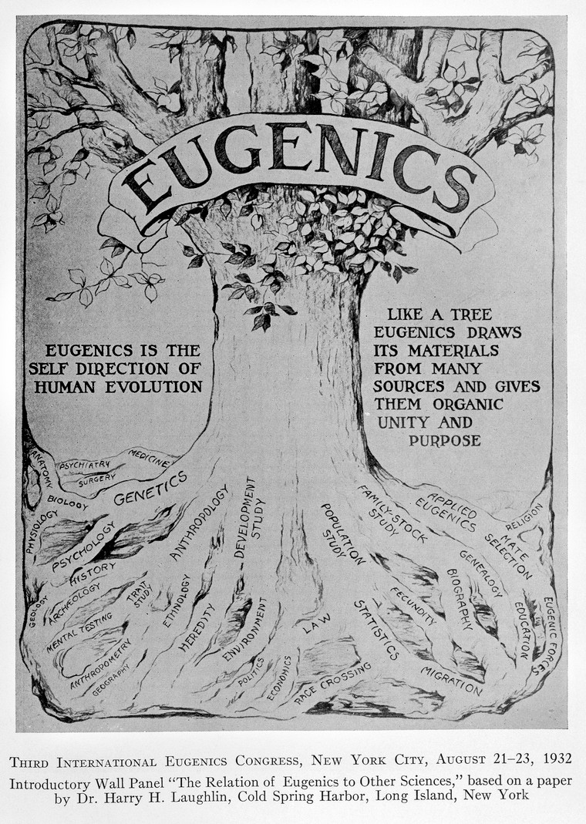This wall panel was based on a paper by eugenicist Harry Laughlin and was presented in 1932 at an international eugenics conference at the American Museum of Natural History.
A decade of progress in Eugenics. Scientific. Credit: Wellcome Collection. CC BY
Erik Parens and Adrienne Asch (2003) wrote a disability rights perspective on prenatal testing. Within their working group, they found that both people with disabilities and parents of children with disabilities disagreed about the purpose and use of prenatal genetic testing:
Although many members of Little People of America would not use prenatal testing to select against a fetus that would be heterozygous for achondroplasia (and who could become a long-lived person with achondroplasia), they might use the test to avoid bearing a child who would be homozygous, because that is a uniformly fatal condition. As participants at the 1997 meeting of the Society for Disability Studies suggested, some people with disabilities would use prenatal testing to selectively abort a fetus with the trait they themselves carry; and some people who would not abort a fetus carrying their own disability might abort a fetus if it carried a trait incompatible with their own understanding of a life they want for themselves and their child. A similar diversity of views toward prenatal testing and abortion can be found among parents raising a child with a disability. (Parens & Asch, 2003, p. 41)
Knowing somebody’s relationship to disability will not tell you how they feel about genetic testing. However, Parens and Asch wrote about shared concerns that disability rights activists have about prenatal tests: “it is the reality of using prenatal testing and selective abortion to avoid bringing to term fetuses that carry disabling traits” (Parens & Asch, 2003, p. 41). They recommend that geneticists and medical providers involved in pregnancy care learn about disability and “identify and overcome biases against people with disabilities” so they can share realistic information with patients (Parens & Asch, 2003, p. 45). So, their disability rights perspective on prenatal testing is that healthcare providers and potential parents deserve accurate information about life with disability and the purpose of testing, as well as the opportunity to consider their values about children and disability before they are confronted with medical decisions. Kruti Acharya (2011) highlighted advances in providing the sort of information for which Parens and Asch were advocating. A 2008 law, the Kennedy-Brownback Pre- and Postnatally Diagnosed Conditions Awareness Act, meant that when doctors tell families about Down syndrome or another impairment, they must give “accurate information” about the impairment and related disability resources (Acharya, 2011, p. 5).
People can submit a sample of saliva or blood and find out whether they have a gene or a change in their genes that is linked to an impairment. Everyone has genetic variations—differences from and changes to what is expected in DNA, which is like our genetic coding. But, certain genetic variations are linked to impairments. While Hansen, Janz, and Sobsey clarify that they believe modern genetic counseling is “not truly eugenic in its intent” (2008, p. S106), they warn that it also does not center disability rights. Even if it is not intended to be eugenics, though, does that necessarily mean that the impact is not eugenics? Hansen, Janz, and Sobsey also state that genetic counseling does not question Darwin’s principles that contributed to eugenics.
Eugenics can involve deciding who deserves to be alive. Eugenics can also involve deciding who is allowed to have babies. Even in 2018, Washington State came under fire for deliberating over a law change that would potentially make it easier for people with disabilities under guardianship to be sterilized against their own will. Autistic advocate and founder of the Autistic Self-Advocacy Network (ASAN), Ari Ne’eman, wrote that Washington State “prohibits guardians from authorizing sterilization without court approval — but the state judicial system is currently considering a proposal […which] advocates with disabilities and the ACLU believe…will streamline the process and increase the number of guardians requesting the sterilization of those under their power” (Ne’eman, 2018).
The right to reproduce is not the only right in jeopardy for people with developmental disability. Although voting rights are supposedly protected under the Voting Rights Act (1964), the Voting Accessibility for the Elderly and Handicapped Act (1984), and the Americans with Disabilities Act (1990), the reality is that people with developmental disability have been prevented from participating in this part of citizenship throughout time. Disability historian Kim E. Nielsen (2012) explains that as far back as in Massachusetts colony of 1641, some people were exempt from public service and criminal punishment and protected from financial decision-making (p. 21). The list included women, children, older adults, and disabled people, illustrating how concepts around cognitive disability have often included groups viewed as different due to race, gender, age, nationality, or sexual orientation and marginalized by systemic oppression. Nielsen (2012) explains, “Between the 1820s and the Civil War, states also began to disenfranchise disabled residents by means of disability-based voting exclusions.…Virginia excluded ‘any person of unsound mind’ from voting in 1830 (it went without saying that women and African Americans were excluded from the vote)” (p. 76). These voting restrictions not only focused on perceived cognitive impairment, but also made a lasting impact to the present day. Switzer reported on a 1997 research study showing that forty-four states had laws that specifically prevented some people with disabilities from voting: “Some states refused to allow whole classes of people to vote (those variously termed idiots, insane, lunatics, mentally incompetent, mentally incapacitated, unsound minds, not quiet and peacable, and under guardianship and/or conservatorship)” (2003, pp. 181-182). Jaqueline Vaughn Switzer (2003) explains that voting is still not a national right for all people with disabilities.
Individuals with developmental disability are prime targets of modern eugenics. While the times and the specifics shifted, the denial of human rights continues for people with developmental disability. However, the history and present of developmental disability is not a straightforward story of victimhood. People with developmental disability resist ableism and advocate for rights. Resistance and self-advocacy offers a path forward for disabled people.

Section 3: Self-Advocacy and Advocacy

The History of the Self-Advocacy Movement
At first, people with developmental disability were spoken over. Locked away in institutions, medicated and sterilized without consent, mistreated and misunderstood, they were not in a position to be viewed as experts in their own lives. People with developmental disability did resist and advocate, but their environments and society at large limited the impact of their actions. Deinstitutionalization is the movement to close institutions, asylums, and state schools. Instead, disabled people live and learn in their communities. Activists organized, advocated, and used legal strategies to work toward the goal of shutting down abusive places like the Willowbrook State School in Staten Island, New York. Some parents and other family members were strong advocates for deinstitutionalization. They became viewed as the voice of their children.
But people with developmental disability had thoughts and opinions of their own. They had their own ideas about themselves, their disability, their community, and what they wanted life to be like. So people with developmental disability began to organize. They met up in groups. They advocated against institutions with the strength and inside information of survivors.
Self-advocates worked together to improve disability rights and fight for deinstitutionalization. Many self-advocacy groups began in the 1970s and 1980s as institutions were called into question and shut down (The Minnesota Governor’s Council on Developmental Disabilities, 2019). Mark Friedman of Speaking For Ourselves, Inc. and Ruthie-Marie Beckwith of People First of Tennessee, Inc. wrote that for early members of Speaking for Ourselves and People First of Tennessee, speaking out about personal experiences in institutions was a powerful part of their advocacy work:
They overcame their fears and lack of experience and began reaching out to their incarcerated counterparts living in institutions. The members’ efforts to expose the nature and insidiousness of their oppression were relentless. As their voices grew in number and volume, so did the resistance they encountered from family members, professionals, family advocates, state officials, unions, and other individuals and entities with extensive conflicts of interest. (2014, p. 239)
As activists, self-advocates with developmental disability faced push-back as they fought to change conditions. Friedman and Beckwith (2014) described barriers like lack of money, transportation, telephones, formal education, and literacy/numeric skills. Additionally, self-advocate group members were often forced to work in sheltered workshops and to ask permission from support staff members to attend meetings. They note that “many of such difficulties that arose were a product of ableism and the effects of incarceration and paternalism, rather than inherent in members’ intellectual disabilities” (p. 239). This reality represents the social model of disability—showing how society disables people through ableist barriers.
As self-advocacy groups grew in power, self-advocates faced danger and roadblocks. Activists with exposed the rampant abuse they had survived in institutions. People with developmental disability continued to face high rates of abuse. Even self-advocates living in the community could be punished for their activism. Friedman and Beckwith (2014) explain, “Self-advocacy chapter members fortunate enough to move out of the institutions were routinely threated with ‘being sent back’ for not complying with minor rules or failing to “fit in” to smaller, but still segregated community homes” (p. 241). Despite these dangers, self-advocates kept fighting. They helped to change their own lives and the lives of other people with developmental disability.
A postcard of Willowbrook State School, a notorious Staten Island, New York institution.
Irma and Paul Milstein Division of United States History, Local History and Genealogy, The New York Public Library. (2015). Willowbrook State School [postcard]. Retrieved from http://digitalcollections.nypl.org/items/510d47d9-ca69-a3d9-e040-e00a18064a99. Public Domain

Self-Advocacy and the Neurodiversity Movement
Neurodiversity is the understanding that all brains are different and that those differences are neutral. Neurodiversity as a concept can be considered particularly well-suited to many types of developmental disability. Judy Singer originated the term “neurodiversity” in the 1990s (Armstrong, 2010, p. 7). Autistic sociologist Damian Milton (2014) defines neurodiversity as follows:
For me, the concept of neurodiversity suggests that variations in neurological development are part of natural diversity, rather than something to be pathologised using a purely medical model of disability, defined by one’s deviation from statistical or idealised norms of observed behaviour. This is not to say that those who identify as autistic people or other forms of neuro-identity do not find life challenging. (p. 11)
Autistic self-advocacy overlapped with and followed in the footsteps of the pioneering self-advocates with intellectual disability and developmental disability. The neurodiversity movement has been around for decades (Kras, 2010; Milton, 2014). According to Joseph Kras, a big moment was when autistic self-advocates responded to the NYU Child Study Center’s 20__ billboard campaign. NYU Child Study Center formatted their disability service advertisements as “ransom notes” written from autism and other disabilities to parents. Here’s what Joseph F. Kras had to say about the Autistic Self-Advocacy Network’s (ASAN) and self-advocates’ response to NYU Child Study Center’s advertising campaign:
Ari Ne’eman and ASAN used the speed and penetration of the Internet to forge alliances with other disability rights organizations to quickly shut down the Ransom Notes campaign. As important, they foregrounded the neurodiversity movement’s evolution away from a paternalistic model of advocacy to one of self-advocacy. (Kras, 2010).
This campaign is one of many successful ventures that used the Internet to connect disability communities for advocacy. Advocacy and self-advocacy among people with developmental disability continues to evolve. Advocates work to make the world better for all people with disabilities.

Evolving Language: Language and the Self-Advocacy Movement
Nowadays, there are many types of advocacy and self-advocacy. Advocates do everything from fight for individual inclusion in the workplace and blog about disability rights to lobby for law changes and educate family members and professionals to participate in protests and civil disobedience. Social media sites, like Facebook and Twitter, have changed activism. People can connect with disability communities through the internet regardless of access to transportation and participate in social media activism campaigns. Language is the focus of some disability activism.
Eugenicists created language like “moron,” “imbecile,” and “idiot”. These terms were once medical labels for people with intellectual disability based on IQ scores. According to Thomas Armstrong (2010),
It was Goddard who first coined the term ‘moron’ (from the Greek word moros, which meant ‘dull’) in 1910, a word that was later applied to people who achieved an IQ score of 51 to 70. Those who scored from 26 to 50 were known as ‘imbeciles,’ and those with an IQ of 0 to 25 were deemed to be ‘idiots.’ These were actual scientific terms used by professionals to describe low-scoring individuals on IQ tests in the first half of the twentieth century. (pp. 141-142)
Once simply medical labels, words like “mentally retarded” devolved into ableist slurs (Barry, 2016). People with intellectual disability, and allies inside and outside of disability communities, have successfully campaigned against use of the “r-word” (Special Olympics, 2017). As Matthew Williams, who has epilepsy and an intellectual disability, said in his 2015 TEDx Talk,
There has been lots of change since Special Olympics began in 1968, but in too many cases, people with intellectual disabilities are invisible to the wider population. People use the r-word in front of me, and they think it doesn’t matter. That’s the word “retard” or “retarded” used in a derogatory manner. They’re not thinking about how much it hurts me and my friends. (Williams, 2015)
Beyond everyday speech, the advocacy also impacted the way the U.S. government writes disability policy. In 2010, President Obama signed Rosa’s Law, which with the purpose “to change references in Federal law to mental retardation to references to an intellectual disability, and change references to a mentally retarded individual to references to an individual with an intellectual disability” (P.L. 111–256, 2010). This legislation amended education, health, and disability rights laws, removing the outdated and offending language and replacing it with preferred language of “intellectual disability.” Rosa’s Law is one example of how language used around disability is important, and why some advocacy focuses on shifting disability terminology.
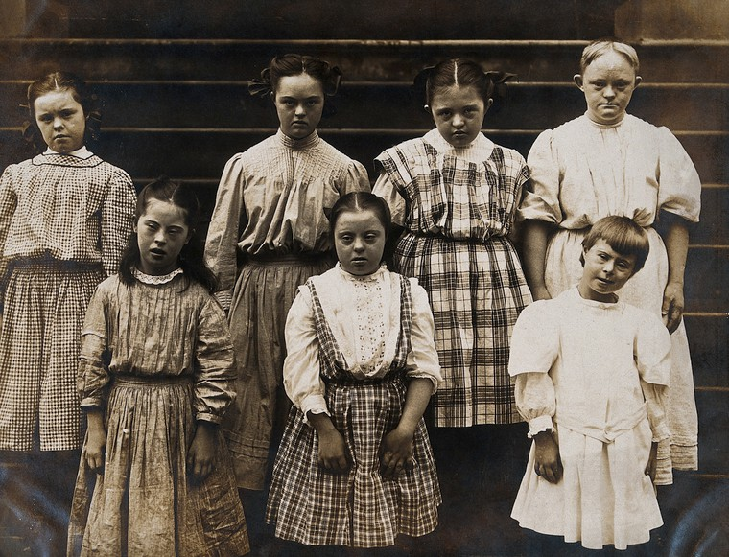Language around developmental disability has changed over time, but offensive terminology remains.
New York State Institute: a group of girls with Down’s syndrome, standing on some steps. Photograph. Credit: Wellcome Collection. CC BY
More language advocacy must still be done at other levels of government. People with developmental disability have higher rates of abuse than nondisabled people. NPR investigated and found that “unpublished Justice Department data on sex crimes… show that people with intellectual disabilities — women and men — are the victims of sexual assaults at rates more than seven times those for people without disabilities” (Shapiro, 2018). Meanwhile, some states still use offensive disability terms from eras when eugenics was considered a legitimate science, especially in legal proceedings. For instance, in court proceedings surrounding sexual assault, the State of New Jersey uses the terms “physically helpless,” “mentally defective,” and “mentally incapacitated” to describe people with developmental, mental health, and/or physical disabilities who are victims/survivors of sexual assault (N.J.S.A. 2C:14-3a [2C:14-2a(7)]). Court proceedings around consent should not dehumanize abuse victims with disabilities and survivors with disabilities through old-fashioned language.
Erasing euphemisms in favor of clear-cut words is another facet of disability language advocacy. Euphemisms are ways of not saying things straightforwardly. So rather than saying somebody has a disability, using a euphemism might mean saying somebody has “special needs.” Lawrence Carter-Long began a social media campaign, #SayTheWord, with this goal in mind, and other disability rights advocates enthusiastically jumped in. Jamie Davis Smith for the Washington Post reported that Carter-Long advocates for “disability” over “special needs”: “‘A need isn’t special if other people get to take the same thing for granted,’ he says, arguing that using terms like ‘special needs’ can obscure access to having those needs met, because they can make ordinary needs seem extraordinary” (Smith, 2017).
Morton Ann Gernsbacher, Adam R. Raimond, M. Theresa Balinghasay, and Jilana S. Boston (2016) agree that euphemisms like “special needs” detract from disability discussions. After the authors created stories about characters, who they either labeled with “special needs,” “a disability,” a specific impairment, or no impairment, they surveyed adults with and without connections to disability, asking them to rank the characters in terms of preference and to complete a free-association task around the words “special needs” and “disability” (p. 6). Free association is when people think of every word that comes to mind about a particular topic. So the researchers would ask their participants to brainstorm about the phrase “special needs,” and the word “disability.” The researchers categorized and analyzed the lists of words associated with “special needs” and “disability.” They concluded that the term “special needs” was vaguer, more negative, and more associated with “special rights” and “segregation” than the word “disability” (p. 9). Interestingly, “Participants were significantly more likely to associate developmental disability with the euphemism special needs than with the term disability” (p. 8). When general public hears “special needs,” they may think of people with developmental disability, but they also link “special needs” to negative words, segregated settings, and the idea that accommodations are going above and beyond. This free association may speak to the stigma and ableism surrounding people with developmental disability in particular. Gernsbacher, Raimond, Balinghasay, and Boston argue against using the euphemism “special needs” for these reasons.
Disability rights advocates are fighting to use the language they choose to define themselves. People in some disability communities overwhelmingly prefer identity-first language (“disabled person”) or person-first language (“person with a disability”). For instance, many autistic people prefer identity-first language (“autistic person”) (Kenny et al., 2015). Communities may collectively prefer one over the other for historical and advocacy-related reasons. In 1999, Jim Sinclair, an autistic advocate and community-builder and co-founder of Autism Network International, argued for identity-first language (“autistic person”) and against person-first language (“person with autism.”) Sinclair’s reasoning was three-fold: One, separation versus integration of identity; two, importance versus lack of importance of identity; and three, moral values attached to identity. Sinclair’s first reason for preferring “autistic person” is that “saying person with autism suggests that the autism can be separated from the person. … Autism is hard-wired into the ways my brain works. I am autistic because I cannot be separated from how my brain works” (Sinclair, 2013). So one argument for identity-first language is integration of disability into a person’s identity, rather than separating disability.
Sinclair’s second reason for preferring identity-first language is that “saying person with autism suggests that even if autism is part of the person, it isn’t a very important part. … We talk about male and female people, and even about men and women and boys and girls, not about people with maleness and people with femaleness” (Sinclair, 2013). In a similar sense, Sinclair argues that “person with autism” makes autism appear incidental, or like something that could be removed or not mentioned without changing the person underneath. Yet Sinclair and many other autistic adults view autism as a core aspect of identity that affects everything else about their experience as a human being. This argument for identity-first language is that disability is an important identity that shapes lives.
Sinclair’s third reason for disliking person-first language is the message it might send about the value of autism, or autistic lives. Sinclair writes:
Saying person with autism suggests that autism is something bad—so bad that is isn’t even consistent with being a person. Nobody objects to using adjectives to refer to characteristics of a person that are considered positive or neutral. …It is only when someone has decided that the characteristic being referred to is negative that suddenly people want to separate it from the person. I know that autism is not a terrible thing, and that it does not make me any less a person. (Sinclair, 2013)
Disability is too often seen as negative. Sinclair resists this negative definition of disability by putting autism at the center, and that autism is a part of or one way of being a person.
Just as Jim Sinclair argues for identity-first language, other people with disabilities argue for person-first language. Some early self-advocates with developmental disability favored “people with disabilities” over “disabled person” due to focusing on personhood rather than impairment. One large self-advocate group got its name because of this very reason. After attending a Canadian self-advocacy conference in 1973, people with developmental disability in Oregon gathered to plan their own the following year (The Minnesota Governor’s Council on Developmental Disabilities, 2019): “At this planning meeting, one man talked about being labeled ‘mentally retarded’ and said, ‘I want to be known as a person first!’ People First was later chosen as the name for a new self-advocacy organization” (The Minnesota Governor’s Council on Developmental Disabilities, 2019). As an act of empowerment, some disabled people seek to reclaim ableist slurs and repurpose these terms for their own use. It’s important to recognize that reclaiming offensive language is only something that members of the marginalized group can do, not people without disabilities. For instance, some people with disabilities choose to refer to themselves as “crips.” Disability studies scholar Simi Linton says, “Cripple, gimp, and freak as used by the disability community have transgressive potential. They are personally and politically useful as a means to comment on oppression because they assert our right to name experience” (Linton, 1998, p. 17). It’s OK for people with disabilities to call themselves words that society recognizes as offensive. It’s best to ask each individual person with developmental disability what language they prefer to be called if they can communicate this information. Otherwise, it’s best to make sure you use respectful, up-to-date language to talk about any person and their disability.
Language can be used to help or hurt, and the words used to describe people can be used to justify discrimination. As the R-Word: Spread the Word to End the Word campaign website puts it, “Language affects attitudes and attitudes affect actions” (Special Olympics, 2017). Why focus on language? Words hold great power.

Language and Developmental Disability
People with developmental disability, like people with any impairment, have diverse experiences and views on their own disabilities. Comedian and actor Zach Anner, who writes about his cerebral palsy, made a video with the Cerebral Palsy Foundation for their “Just Say Hi” campaign (2015), which urged strangers to greet people with cerebral palsy and other disabilities. In response to the Cerebral Palsy Foundation’s “Just Say Hi” campaign, disability rights scholar Kim Sauder, who has cerebral palsy, noted, “rather than telling people to ‘just say hi’ a more appropriate lesson would be to make it clear that disabled people should have the right to exist in public without comment” (2015, para. 13). None of us can assume that we know which terms a person with a specific impairment prefers. Even two people with the same impairment might want to be called different terms.
Just because somebody has a diagnosis does not mean that they will identify with the diagnosis, or even identify as disabled at all! The same label might mean vastly different things to two people. Rebecca Monteleone and Rachel Forrester-Jones (2017) interviewed fifteen British people labeled with intellectual disability. Some research participants had created their own definition of intellectual disability related in part to how others had treated them, and affirmed stigma surrounding intellectual disability. Monteleone and Forrester-Jones explained, “Identification of disability primarily relied on physical or tangible experiences of disability. The experience of disability in oneself was often accompanied by self-degradation or feelings of injustice, and the judgement of others played a role in perceptions” (Monteleone & Forrester-Jones, 2017, p. 308). They also found that some people with intellectual disability were unfamiliar with common disability terminology and uncomfortable talking about disability. The authors called for more accessible language access.
Dan Barry investigated a group of mistreated men. The men had intellectual disabilities. They worked in a meat processing plant in Iowa. Barry wrote about what he found in the New York Times. He also talked about words surrounding intellectual disability in the United States. Barry explained that language about intellectual disability has shifted over time. He wrote,
By the 1950s, the accepted term had become mental retardation. … But no matter how well-intentioned, this term also devolved into a pejorative, posing a problem for groups and government agencies whose names included the r-word. And as people with intellectual disability moved out of institutions and took their rightful place in the community, they began to advocate for themselves—and to express their loathing for the word “retarded.” (Barry, 2016, paras. 16-17)
Disability language continues to change over time. What is acceptable in one era is frowned upon in the next. Lawrence Carter-Long explained that over the course of his life, from the late 1960s to the present, “while my condition hasn’t changed, I’ve been called handicapped, handi-capable, disabled, differently-abled, and a person with a disability — the latter being an understandable attempt primarily by parents of disabled children to separate the disability from the person” (King, 2016). Despite the numerous different labels applied to his life, Carter-Long emphasizes that “my condition hasn’t changed” (King, 2016). What he means by this statement is that the view of him as a person, the view of his impairment, and the “proper” way to talk about disability changed rapidly. But the whole time that he was referred to by differing labels, Carter-Long still had the same impairment, cerebral palsy. He didn’t change, though the disability terminology changed, and in some ways, society’s view of him and his disability changed, too. Terms fluctuated from the offensive to the euphemism, from identity-first to person-first.
Advocacy and self-advocacy helped shut down Pennhurst State School and Hospital, a Pennsylvania institution known for abuse and violence against people with developmental disability. One crumbling and abandoned campus building is shown here in 2014.
No Admittance. Photograph. Thomas James Caldwell. CC BY

Putting the Social Model of Disability into Practice
Indeed, the experiences that people have are shaped by their environment and their access to resources. Stephen J. MacDonald (2009) studied people with dyslexia in the United Kingdom. MacDonald looked at their experiences through a social model of disability lens. He surveyed 77 people with dyslexia. Then he conducted qualitative interviews. He interviewed 13 people from different socioeconomic status (p. 353). He found that schools and workplaces created disabling barriers for people with dyslexia. In other words, school and work can be inaccessible for some people with learning disabilities. In the UK, MacDonald learned that middle-class people with dyslexia accessed private tutoring and school tuition. Middle-class people with dyslexia had more flexible employment. They accessed assistive technology. The barriers caused more problems for working-class people with dyslexia because they did not have the same resources that middle-class people with dyslexia did (2009, p. 359). When investigating the experiences of people with dyslexia in schools, MacDonald notes that “literacy skills are often seen as a measurement of success in the culture of contemporary education” (p. 354). Western societies disable people with dyslexia by focusing on literacy and accessing literacy through traditional reading.
It’s important to learn the history, theories, and concepts of disability studies, but how do we put the social model of disability into practice for people with developmental disabilities? What do these concepts look like in practice? Even in environments that don’t view developmental disability from a social model perspective, such as schools, it is possible to apply disability studies to work with individuals. Focusing on inclusion means providing an education that works for a variety of students with and without disabilities. Using both existing models of successful inclusive schools and the precepts of neurodiversity, Thomas Armstrong puts the social model of disability into action by suggesting specific qualities that inclusive education should hold. First, inclusive classrooms that work for neurodivergent students, including students with developmental disabilities, should be welcoming to students from any “culture, race, gender, and sexual orientation,” disabled students with a variety of impairments, and nondisabled students (2012, p. 195). Rather than being either a general education classroom with mainstreamed students with disabilities or a special education classroom, teachers value students’ different backgrounds and emphasize that “there is no such thing as a normal student” (p. 197). Instead of including just one teacher, Armstrong recommends involving many caring educators and assistants, from multiple co-teachers with general and special education training to “tutors, aides, parent volunteers, specialized service personnel” and “the students themselves, engaging in teaching one another” (p. 199).
Including people with developmental disability at school is one way to put the social model of disability into practice.
Young girl with Down’s syndrome [sic] playing with friends. Credit: Fiona Yaron-Field. CC BY
Beyond explicitly welcoming all students and involving caring human relationships in learning, Armstrong speaks to the need for providing a multitude of activities and approaches to best engage students’ strengths. Armstrong explains, “The neurodiverse classroom celebrates and teaches about diversities of all kinds” (p. 197). He recommends working race, culture, gender, sexuality, and disability into curricula as well as infusing lessons with histories of famous neurodivergent people, involving family and community members with developmental, learning, and mental health disabilities in classwork, and stocking the classroom with materials that highlight people with developmental, learning, and mental health disabilities (p. 197), and using assistive technology such as communication devices, reading and writing software (p. 198). Armstrong suggests using Universal Design for Learning: “In the classroom, universal design refers to removing barriers to learning for kids with disabilities in ways that also enhance everyone’s ability to learn” (pp. 196-197). He profiles the William W. Henderson Inclusion Elementary School, from Massachusetts, which gives meaning to the term “presuming competence”:
Students study Shakespeare, for example, but in different ways. Some read with their eyes, some with their fingers; one interprets it with a drawing, while another performs a skit. A fifth-grade teacher engages her students in a lesson on the literary genre of memoir. Some will read bound books. Some will listen to an audiotape. Others will use a computer program that displays and speaks the words of a scanned book. Individual students have specific instructional enhancements added to help them master the material according to their unique gifts and needs. The speech therapist constructs a set of voice recordings and picture symbols for Betsaida (who is nonverbal) so she can communicate her needs more successfully. The biology teacher creates a chart listing ways that Joshua (who has mild cognitive delays) can take responsibility for certain activities in the lab. The art teacher keeps a box of varying grips with her so that students with fine motor difficulties can better use drawing and painting implements. (Armstrong, 2010, p. 192)
Schools have found ways to make students with developmental disability engaged in learning and included in the community. Some of these concepts come from disability rights advocates and disability studies.

Conclusion: Advocacy in the Future
The social model of disability and the neurodiversity paradigm can help show problems and discrimination. More importantly, the social model and neurodiversity can design solutions to make life better for people with developmental and learning disabilities. In his investigation of neurodiversity, educator and researcher Thomas Armstrong (2010) advocates for what he calls “niche construction”—what disability studies scholars would call removing societal barriers. Armstrong writes that for neurodivergent people, “instead of always having to adapt to a static, fixed, or ‘normal’ environment, it’s possible for them (and their caregivers) to alter the environment to match the needs of their own unique brains” (2010, p. 18).
Advocates with developmental disability have paved a path toward better tomorrows for all disabled people. When it comes to disability rights, there is still far to go for people with developmental disability. From inclusion and accessibility in the community and access to supports for a self-directed life to shifting language around disability and fighting violence against disabled people, there are many fights ahead. The self-advocacy movement has proven that change can be made and fights can be won.
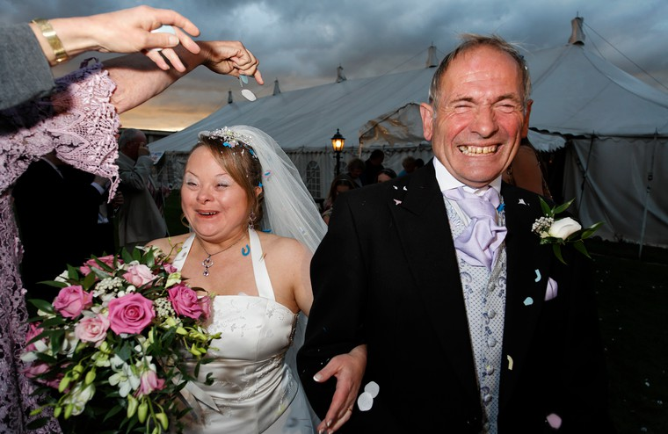People with developmental disability are advocating for the right to live a self-determined life.
Bride and groom on their wedding day, Down’s syndrome. Credit: Fiona Yaron-Field. CC BY
Top of Form

References
Aggravated Criminal Sexual Contact (Victim Helpless, Mentally Defective/Incapacitated) N.J.S.A. 2C:14-3a [2C:14-2a(7)]. (2/7/2012)
Anner, Z. (2015). Zach Anner. Retrieved from http://yourcpf.org/just-say-hi/zach-anner/
Acharya, K. (2011). Prenatal testing for intellectual disability: Misperceptions and reality with lessons from Down syndrome. Developmental Disabilities Research Reviews, 17 (1): 27–31. doi:10.1002/ddrr.135.
Armstrong, T. (2010). The power of neurodiversity: Unleashing the advantages of your differently-wired brain. Perseus Books Group: Cambridge, MA.
Barry, D. (2016, May 8). Giving a name, and dignity, to a disability. The New York Times. Retrieved from https://www.nytimes.com/2016/05/08/sunday-review/giving-a-name-and-dignity-to-a-disability.html
Ball, N. (2013, September 13). Darwin, Charles. Retrieved from http://eugenicsarchive.ca/discover/tree/523377f35c2ec50000000050
Berlin : Volksgesundheits- und Betriebsführungs Bilderdienst. (Berlin SW68 : Wirtschafts Werbeverlag Curt Cowall). (1933/1945). People should be open and candid with their doctors about hereditary illnesses, so that the German state can act to eliminate them [Color lithograph]. Retrieved from https://wellcomecollection.org/works/v3y2r5xq
Buck v. Bell, 274 U.S. 200 (1927)
Caldwell, T. J. (2014). No admittance: Pennhurst State School and Hospital, Limerick Building [photograph]. Retrieved from https://www.flickr.com/photos/photommo/45856142725/
Cowley, D. M. (2016). A tale of two transitions. In M. Cosier & C. E. Ashby (Eds.), Enacting change from within: Disability studies meets teaching and teacher education. New York, New York: Peter Lang (103-130).
Czech, Herwig. (2018). Hans Asperger, National Socialism, and “race hygiene” in Nazi-era Vienna. Molecular Autism, 9 (29): 1-43. https://doi.org/10.1186/s13229-018-0208-6
Darwin, C. (2009). On the origin of species. New York: Penguin Classics. (Original work published 1859).
Davis, L. J. (2013). Introduction: Normality, power, and culture. In L. J Davis (Ed.), The disability studies reader (4th ed.). New York, New York: Routledge. (1-14).
Dyrbye, E. (n.d.). “Eugenics” coined by Galton. Retrieved from http://eugenicsarchive.ca/discover/tree/523377f35c2ec50000000050
Eugenics Society. (n.d.). Portrait photograph of Charles Darwin [photograph]. Retrieved from https://wellcomecollection.org/works/b2a4kgcx
Friedman, M. & Beckwith, R. M. (2014). Self-advocacy: The emancipation movement led by people with intellectual and developmental disabilities. In L. Ben-Moshe, C. Chapman, & A. C. Carey (Eds.), Disability incarcerated: Disability and imprisonment in the United States and Canada. New York, New York: Palgrave McMillan. (237-254).
Gernsbacher, M. A., Raimond, A. R., Balinghasay, M. T., & Boston, J. S. (2016). “Special needs” is an ineffective euphemism. Cognitive Research: Principles and Implications, 1: 29. DOI 10.1186/s41235-016-0025
Goddard, H. H. (1914). H.H. Goddard, Feeble-mindedness: its causes and consequences [Photograph]. Retrieved from https://wellcomecollection.org/works/ddzdnt38
Hansen, N. E., Janz, H. L., & Sobsey, D. J. (2008). 21st century eugenics? The Lancet: S104-S107. DOI: https://doi.org/10.1016/S0140-6736(08)61889-9
Hentoff, N. (1999, September 11). A professor who argues for infanticide. Washington Post. Retrieved from https://www.washingtonpost.com/archive/opinions/1999/09/11/a-professor-who-argues-for-infanticide/cce7dc81-3775-4ef6-bfea-74cd795fc43f/?utm_term=.5a32498ddd5b.
Irma and Paul Milstein Division of United States History, Local History and Genealogy, The New York Public Library. (2015). Willowbrook State School [postcard]. Retrieved from http://digitalcollections.nypl.org/items/510d47d9-ca69-a3d9-e040-e00a18064a99
Kenny, L., Hattersley, C., Molins, B., Buckley, C., Povey, C., & Pellicano, E. (2015). Which terms should be used to describe autism? Perspectives from the UK autism community. Autism: 1-21. DOI: 10.1177/1362361315588200
King, B. J. (2016). Disabled: Just #SaytheWord. Retrieved from https://www.npr.org/sections/13.7/2016/02/25/468073722/disabled-just-saytheword.
Kras, J. F. (2010). The “ransom notes” affair: When the neurodiversity movement came of age. Disability Studies Quarterly, 30 (1): http://www.dsq-sds.org/article/view/1065/1254.
Kurbegovic, E. (2014, April 29). Social Darwinism. Retrieved from http://eugenicsarchive.ca/discover/tree/523377f35c2ec50000000050
MacDonald, S. J. (2009). Windows of reflection: Conceptualizing dyslexia using the social model of disability. Dyslexia, 15: 347–362.
Linton, S. (1998). Claiming disability: Knowledge and identity. New York, New York: New York University Press.
Milton, D. (2014). So what exactly are autism interventions intervening with? Good Autism Practice, 15 (2): 6-14.
Monteleone, R. & Forrester-Jones, R. (2017). ‘Disability means, um, dysfunctioning people’: A qualitative analysis of the meaning and experience of disability among adults with intellectual disabilities. Journal of Applied Research in Intellectual Disabilities, 30: 301–315.
Ne’eman, A. (2018, January 29). Washington State may make it easier to sterilize people with disabilities [blog post]. ACLU. Retrieved from https://www.aclu.org/blog/disability-rights/integration-and-autonomy-people-disabilities/washington-state-may-make-it
Nielsen, K. E. (2012). A disability history of the United States. Boston, MA: Beacon Press.
The Minnesota Governor’s Council on Developmental Disabilities. (2019). The first self-advocacy conferences. Retrieved from http://mn.gov/mnddc/parallels/seven/7b/3.html
Parens, E. & Asch, A. (2003). Disability rights critique of prenatal genetic testing: Reflections and recommendations. Mental Retardation and Developmental Disabilities Research Reviews, 9: 40-47.
Roberts, J., & Middleton, A. (2018). Genetics in the 21st Century: Implications for patients, consumers and citizens. F1000Research, 6: 2020. doi:10.12688/f1000research.12850.2
Roige, A. (2014, April 29). Intelligence and IQ testing. Retrieved from http://eugenicsarchive.ca/discover/tree/523377f35c2ec50000000050
Rosa’s Law. PUBLIC LAW 111–256—OCT. 5, 2010 124 STAT. 2643
Sauder, K. (2015, December 14). In defense of the radical idea of letting disabled people exist in public without comment [blog post]. Retrieved from https://crippledscholar.com/2015/12/14/in-defense-of-the-radical-idea-of-letting-disabled-people-exist-in-public-without-comment/
Shapiro, J. (2018, January 8). The sexual assault epidemic no one talks about. National Public Radio. Retrieved from https://www.npr.org/2018/01/08/570224090/the-sexual-assault-epidemic-no-one-talks-about.
Shuttleworth, G. E. (n.d.). New York State Institute: a group of girls with Down’s syndrome, standing on some steps [Photograph]. Retrieved from https://wellcomecollection.org/works/th8d3n6a
Silberman, S. (2015). Neurotribes: The history of autism and the future of neurodiversity. New York, New York: Avery.
Sinclair, J. (2013). Why I dislike “person first” language. Autonomy, the Critical Journal of Interdisciplinary Autism Studies, 1 (1). Retrieved from http://www.larry-arnold.net/Autonomy/index.php/autonomy/article/view/OP1.
Simons Powering Autism Research. (2019). About SPARK. Retrieved from https://sparkforautism.org/portal/page/about-spark/
Simons Powering Autism Research. (2019). FAQ. Retrieved from https://sparkforautism.org/portal/page/faqs/
Smith, J. D. (2017, September 28). My daughter doesn’t have “special needs.” She’s disabled. Washington Post. Retrieved from https://www.washingtonpost.com/news/parenting/wp/2017/09/28/my-daughter-doesnt-have-special-needs-shes-disabled/?noredirect=on&utm_term=.f805ea2617d9.
Special Olympics. (2017). Why pledge? R-Word. Retrieved from https://www.r-word.org/r-word-why-pledge.aspx#
Switzer, J. V. (2003). Disabled rights: American disability policy and the fight for equality. Washington, D.C.: Georgetown University Press.
The Williams & Watkins Company. (1932). A decade of progress in Eugenics [Wall panel]. Retrieved from https://wellcomecollection.org/works/aa3f266q
Walsh, P., Elsabbagh, M., Patrick Bolton, P., & Singh, I. (2011). In search of autism biomarkers Nature Reviews Neuroscience, 12: 603-612.
Wellcome Collection. (n.d.). Saint Valentine blessing an epileptic [colored etching]. Retrieved from https://wellcomecollection.org/works/sw3xfmgf
Williams, M. (2015, November). Matthew Williams: Special Olympics let me be myself – a champion. Retrieved from https://www.ted.com/talks/matthew_williams_special_olympics_let_me_be_myself_a_champion
Yaron-Fields, F. (2019). Bride and groom on their wedding day, Down’s syndrome [photograph]. Retrieved from https://wellcomecollection.org/works/ycduqbye
Yaron-Fields, F. (2019). Young girl with Down’s syndrome playing with friends [photograph]. Retrieved from https://wellcomecollection.org/works/tnydxx3w

Glossary
- Ableism: structural discrimination against disabled people.
- Bioethics: relates to the study moral questions about life and living beings.
- Biomarker: a measurable, predictable biological indicator of a specific condition that can identify potential diagnoses and/or treatments.
- Deinstitutionalization: the movement to close institutions, asylums, and state schools.
- Eugenics: the idea that some people are smarter, healthier, and better because of their genes.
- Eugenicist: people who studied, practiced, and believed in eugenics.
- Euphemism: a way of not saying things straightforwardly.
- Free Association: when people think of every word that comes to mind about a particular topic.
- Genetic Counselor: a professional who understands genetic conditions, discusses test results, and advises patients of options for treatment and reproduction.
- Genetic Variation: differences from and changes to what is expected in DNA.
- Medical Model of Disability: disability is seen as an individual problem that requires medical intervention.
- Natural Selection: Charles Darwin’s theory that the animals (including ancestors of humans) who adapted best to their environment and had the best qualities would be most likely to survive, mate, and have offspring.
- Neurodiversity: the understanding that all brains are different and that those differences are neutral.
- Social Darwinist: person who used Darwin’s theories to try to understand society and thought that groups of people who were struggling were biologically worse.
- Social Model of Disability: disability is seen as a byproduct of society’s ableist barriers.

